1. Which are the top three variables in your model which contribute most towards the probability of a lead getting converted?

**The top three variables in the model which contributes most towards the probability of a lead getting converted are**

* **‘Total Visits’,**
* **‘Total Time Spent on Website’**
* **‘Lead Origin_lead add’**

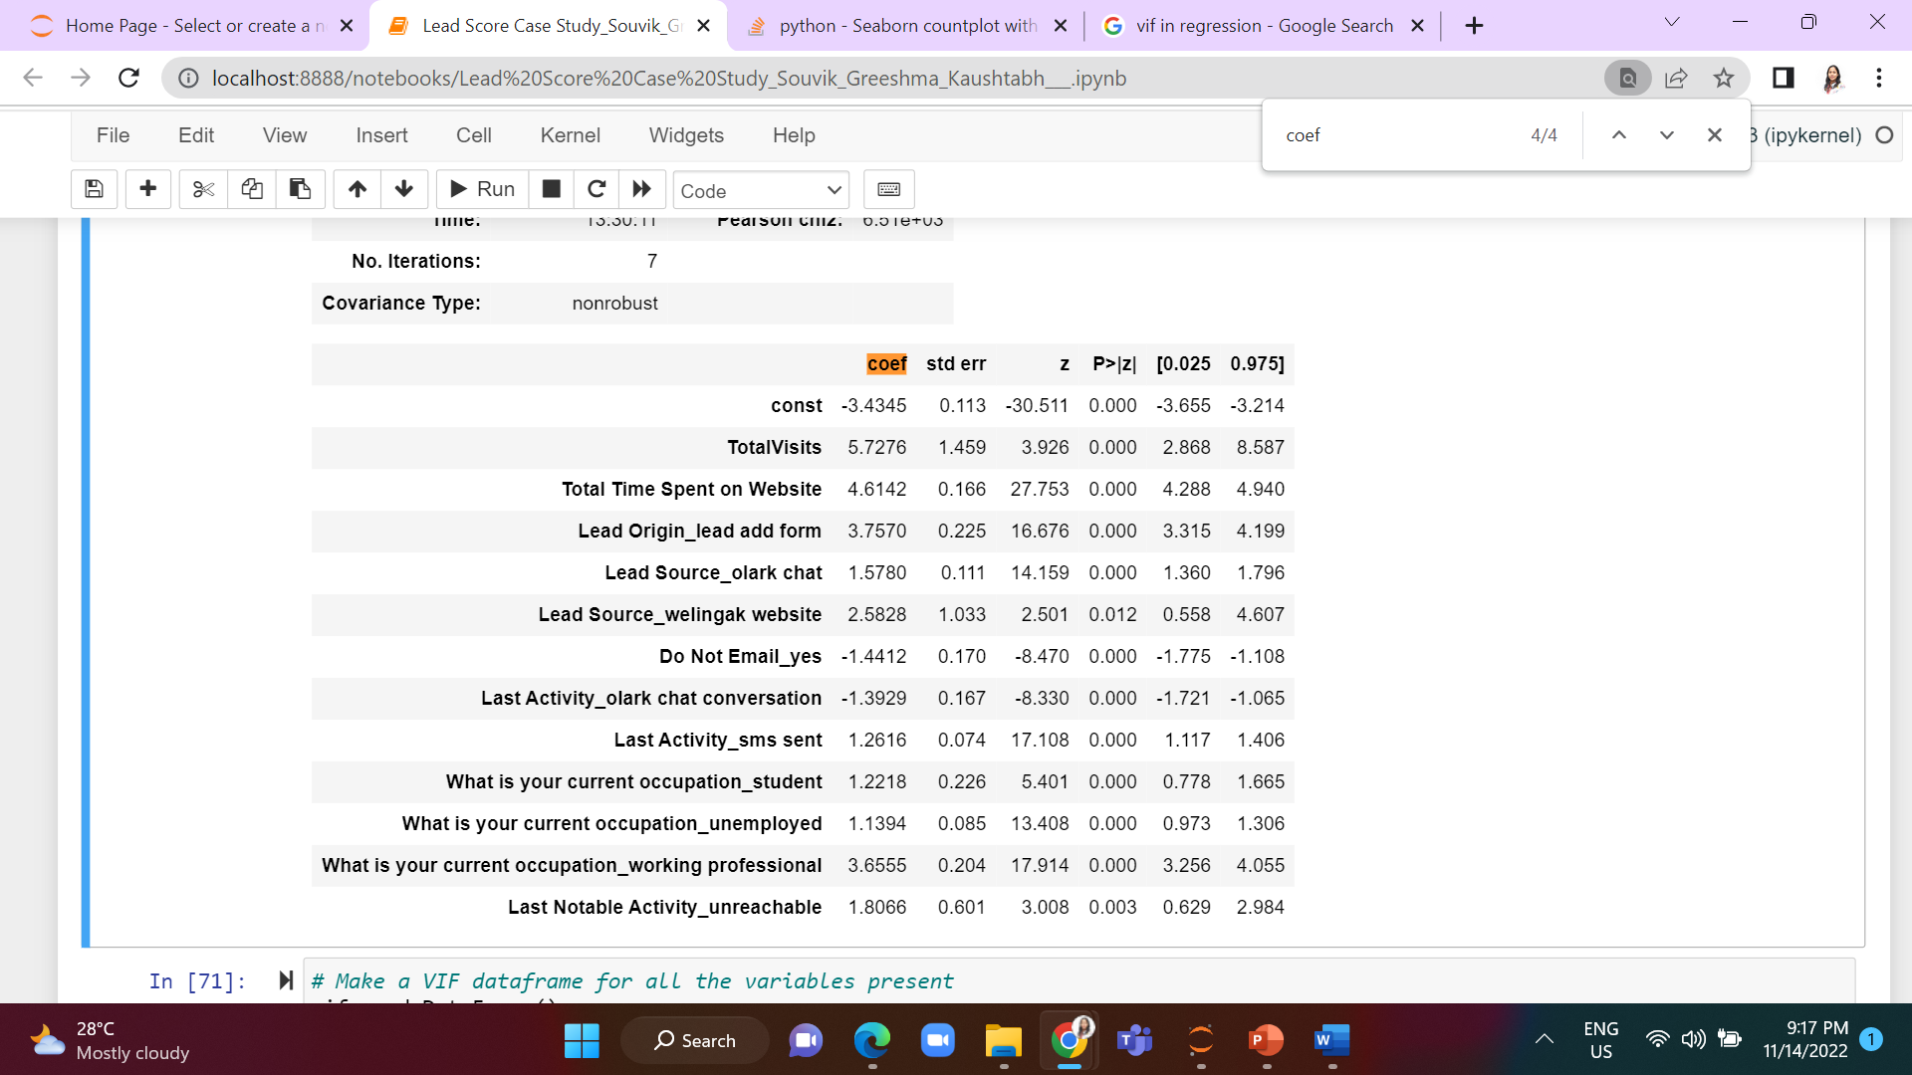

1. What are the top 3 categorical/dummy variables in the model which should be focused the most on in order to increase the probability of lead conversion?

**The top 3 categorical/dummy variables in the model which should be focused the most on in order to increase the probability of lead conversion are**

* **‘Lead Origin_lead add’**
* **‘What is your current occupation_working professional’**
* **‘Lead Source_welingak website’**

1. X Education has a period of 2 months every year during which they hire some interns. The sales team, in particular, has around 10 interns allotted to them. So during this phase, they wish to make the lead conversion more aggressive. So they want almost all of the potential leads (i.e. the customers who have been predicted as 1 by the model) to be converted and hence, want to make phone calls to as much of such people as possible. Suggest a good strategy they should employ at this stage.

**The below table represents the data based on cutoff 0.35. So, in order to make the lead conversion more aggressive, the company may call all the leads with conversion probability value 1 under a cutoff of 0.3.**

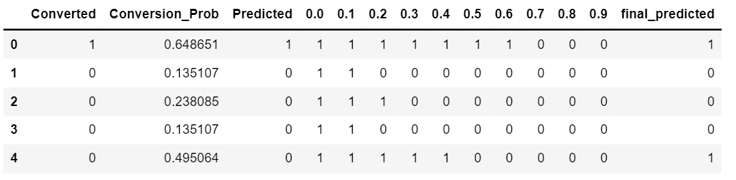

1. Similarly, at times, the company reaches its target for a quarter before the deadline. During this time, the company wants the sales team to focus on some new work as well. So during this time, the company’s aim is to not make phone calls unless it’s extremely necessary, i.e. they want to minimize the rate of useless phone calls. Suggest a strategy they should employ at this stage.

**To minimize the rate of useless phone calls, the company may call all the leads which have a conversion probability (value = 1) under column 0.7. So that most potential users will be converted.**